Asexual Reproduction in fungi
Asexual reproduction by vegetative methods takes place mainly by fragmentation, fission and budding. But by spores, it takes place by the formation of nonflagellated spores e.g conidia. However, some genera reproduce by oidia or chlamydospores.
Fragmentation is common in filamentation Ascomycetes.
Fission is seen in unicellular Ascomycetes, especially in yeats. There occur a simple splitting of a cell into two daughter cells as shown in fig 12.1 A-D. by constriction and cell wall formation. The nucleus also divides mitotically into daughter nuclei, each of which enters into newly formed daughter cells.
conid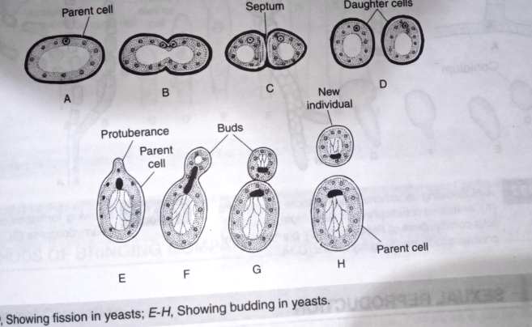
Budding is the production of small protuberance or bud from a parent cell (fig 12.1 E-G) as in yeats. The bud increases in size, breaks off eventually from a parent cell and develops into new individual as shown in fig 12.H. Sometimes chains of buds are formed, and the entire structure appears as a false mycelium or pseudomycelium.
Conidia are the most commonly occurring spores in Ascomycetes. Conidium is a non-motile, deciduous, exogenously produced asexual spore, which develops at the free end of a special hypha called conidiophores. Usually conidiophores cuts conidia in a rapid succession, resulting into a chain of conidia. The condiophores may be unbranched (e.g Erysiphe, as shown in fig 12.2 A) or branched (e.g Penicillum as shown in fig 12.2 B), unicellular in Phyllosticta as fig 12.2c or multicellular as in Penicillum as shown in fig 12.2 B.
In Penicillum, Aspergillus and in many other genera the ultimate branchs of conidiospores bear some bottle-shaped structure called sterigmata .The conidia in Aspergillus, remain arranged on the condiophore in a basipetal succession i.e youngest at the base and oldest at the top of the chain. However, in some genera they develop in acropetal succession i.e oldest at the base and youngest at the top. On getting detached each conidium swells as shown in fig 12.2D,E., gives rise to a germ tube as shown in fig 12.2 F,G and develops into a young mycelium.

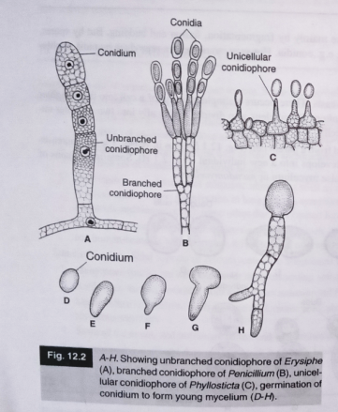

Oidia or arthrospore are single-celled, thin walled spores formed simultaneously throughout the length of a hyphae as shown in fig 12.3 A. They are actually the breakup cells of the hyphae.

Chlamydospore are the large, thick walled spores shown in fig 12.3B formed in the mycelium. A lot of reserve food remain acculmulated in chamydospore. They are generally intercalary in position, but sometimes they may also be terminal.

